Asynchronous Communication

Energy Utility Platform

Analysis and Design Document

Student:Stefana Chelemen

**Group:30241**

# Elaboration – Iteration 1.1

# Domain Model

The application will have the following models: UserModel, DeviceModel, DataMonitoringModel

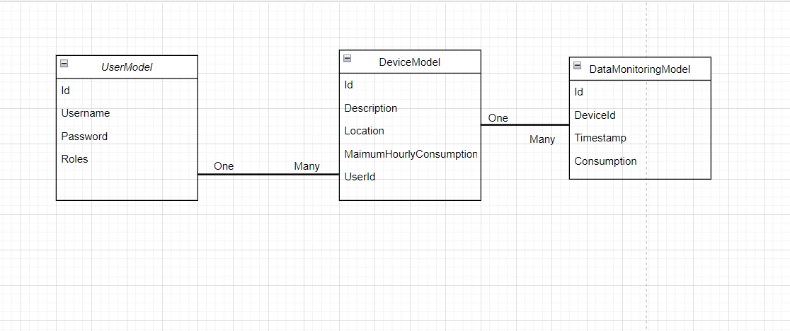

# Architectural Design

## Conceptual Architecture

## Three-tier architecture is a well-established software application architecture that organizes applications into three logical and physical computing tiers: the presentation tier, or user interface; the application tier, where data is processed; and the data tier, where the data associated with the application is stored and managed. Also, it will be a Client-Server application, where multiple clients will request services from the server and the server will send back a response to the request.

We will use a relational database to store out data, and this is how we will be manipulating our data.

For the user interface, I used the Javascript’s open source library-React.

To operate my application in the cloud I used Heroku, is a platform as a service (PaaS) that enables developers to build, run, and operate applications entirely in the cloud.

I also used docker for managing my application. Docker is an open source software platform to create, deploy and manage virtualized application containers on a common operating system (OS), with an ecosystem of allied tools.

I also added a Smart Metering Device Simulator module to act as a Message Producer. It simulates a

sensor by reading energy data from a file (sensor.csv - one value at every 10 minutes) and sends

data in the form < timestamp, device_id, measurement_value > to the Message Broker (i.e., the

queue). For the message Broker I used RabbitMQ as a service fom https://www.cloudamqp.com/.

## Package Design

## Component and Deployment Diagrams

# 

## Class Design

